**IT5016D: Software Development Fundamentals**

**Assessment 2: Software Development Life Cycle**

|  |  |
| --- | --- |
| **Student Name:** | **David Jacobs** |
| **Student ID:** | **20230671** |
| **Due Date:** | **19 / 4 / 2023** |

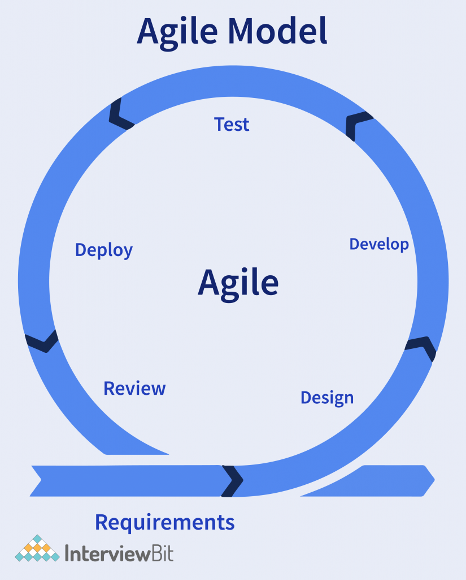

**Requirements**

* The ticketing system needs to be created with input fields.
* Some of these fields need to be changeable.
* The tickets also needs to be stored and then retrieved for viewing.
* A count of active, open and closed tickets needs to be included in the program and displayed on a consol.
* A password needs to be generated if the ticket issue is a password change.
* One field must be for a ticket response with the initial comment

‘Not Yet Available’.

* The program must use two classes, a ‘Ticket’ class and a ‘Main’ class.

**Design**

The help desk ticketing system is an application that is accessible to every employee of the organization.

It will have 4 input fields as listed below.

* Creator’s name
* Client’s staff ID
* Client’s email address
* A description of the issue

Upon creation of a ticket the ticket response will set as ‘Not Yet Available’. This can be changed with the ‘Add response’ option on the main menu.

Upon creation of a ticket the ticket status will be set as Open. This will automatically be updated to Closed once the ticket response is updated.

The ticket numbers will be automatically assigned starting at 2001 and incrementing by +1 for all subsequent tickets

If the ticket description contains the words ‘password’ and ‘change’ a new password will be created with the first 2 numbers of the client’s staff ID followed by the first 3 letters of the creator’s name. In this instance the ticket will automatically be closed.

To change the ticket response the ticket must be open. If the ticket is closed the ticket must be reopened to add a response

The program will have an exit option to end program

**Development**

* 10 / 3 / 2023

Created a GIT Hub repository

* 6 / 3 / 2023

Started coding the program in accordance with the requirements and design specifications.

* 7 / 4 / 2023

Development update. I have created a main menu function with program options and am working on a function called TicketInput with all the input statements for the necessary fields.

* 8 / 4 / 2023

Uploaded edited files from my pythonProject7 folder through GIT to GIT Hub.

* 12 / 4 / 2023

Development update. I have created a function called Printticket that displays all submitted tickets.

I have created a function to manage the ticket response input and a function to manage the reopening of tickets.

Uploaded edited files from my pythonProject7 folder through GIT to GIT Hub.

* 13 / 4 / 2023Development update. I am currently testing and designing my program. I have created a ticket status field option on the main menu that displays each ticket’s status whether Open or Closed. A closed ticket must now be reopened to add a response.

I have added a new function called TicketStatistics which prints the number of tickets submitted, the number of resolved ticket and the number of open tickets.

I have put the ticket statistics output into a function. The function is working properly.

* 14 / 4 / 2023

Development update. I am currently testing and designing my program. I have added a new input field called ‘response’ to update the ticket response. The program functions but not optimally.

* 16 / 4 / 2023

Development update. The input fields are all working correctly. The global variables for tracking the status of tickets is working correctly transferring updated values. The home page class Main() is complete and working correctly. The TicketInput function is complete and working correctly. The ticket viewing function Printticket() is complete and working correctly. The ticket update functions respond and reopen are complete and working correctly. The program executes and runs without errors except for the ticket select input which throws an error if something different is inputted

* 19 / 4 / 2023

The error issues I had with ticket number input have been resolved. Only valid ticket number are excepted with prompt to re-enter if the inputted value is a string or a integer that is not a ticket number.

* 21 / 4 / 2023

I have tested my program and all its functions and it is now ready to upload to Git Hub and submit to my tutor.

I have created a new ReadMe file in my GIT Hub account called ‘User Manual’.

I have uploaded edited files from my pythonProject7 folder through GIT to GIT Hub

**Test**

I have run the program continuously and have checked every input option and variable reassignment is working properly. All my code is working exactly as it should and there are no issues with the codes logical flow. Also there are no typos in the print outputs with appropriate spacing between lines to make the output clearly understood.

**Deploy**

My program is complete and ready to go live.

**Review**

My program meets all assessment requirements. It functions correctly and I do not need to iterate the Software Development Lifecycle again in this case.